SETTING OUT A MUSICAL EXAMPLE:

A music example/figure is a quotation, so you must format and cite the example correctly. Turabian terminology uses "figure" instead of "example." You can insert music figure into your paper by photocopying from a score, or using Finale, Sibelius, or other score-writing programs.
Formatting the music figure:
1. Include the clef(s). If the measures you've copied from the score do not include clefs, then add them yourself on each line of the example.
2. Include measure numbers. Remember to use mm. for multiple measures (ms. means "manuscript"). example: mm. 36-39.
3. Give a title to your figure. Typically: Figure Number. Composer First Name Last, Title of work, measure numbers. Footnote subscript.
Figure 1-3. Johann Sebastian Bach, Sarabande from Violoncello Suite No. 2 in D minor, BWV 1008, mm. 16-19.³
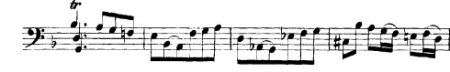
(A)
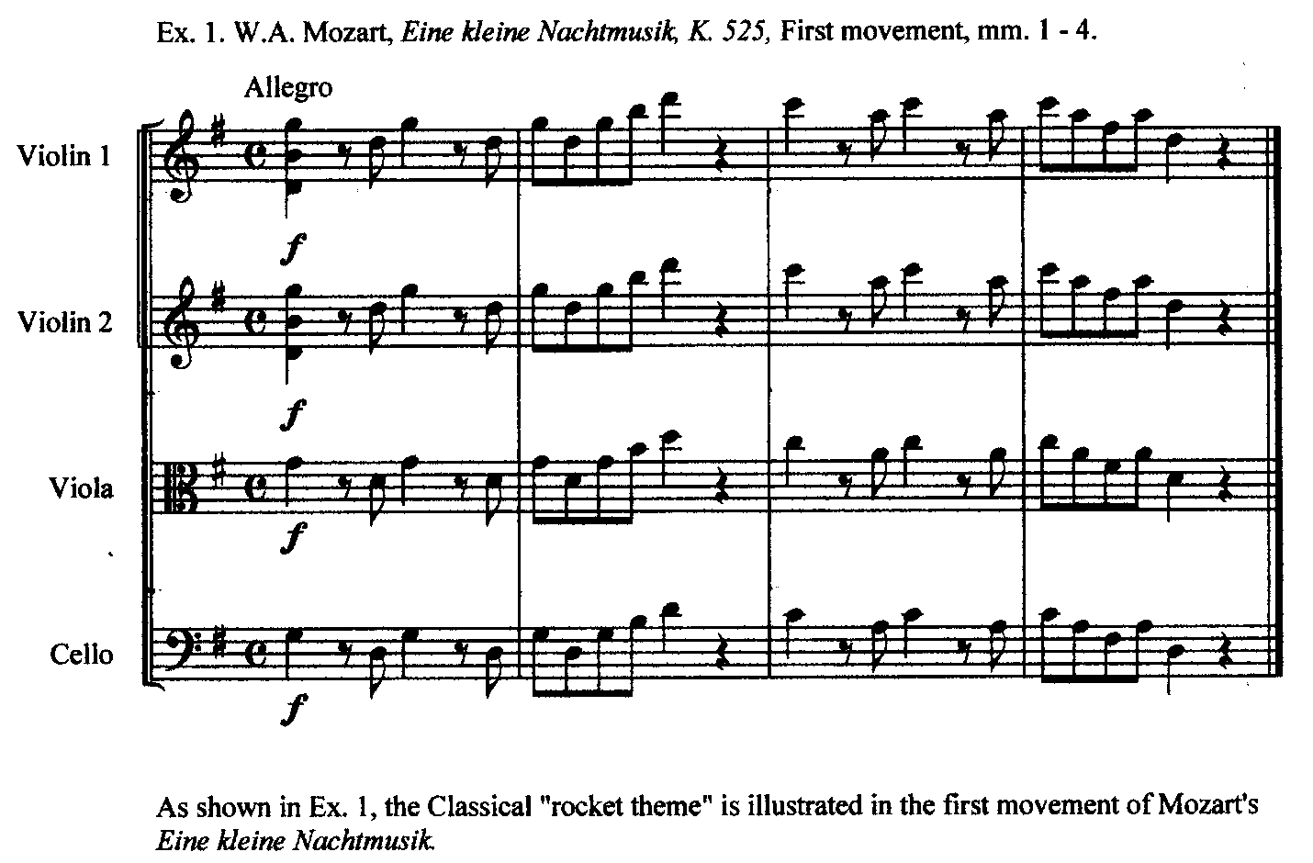

(B)
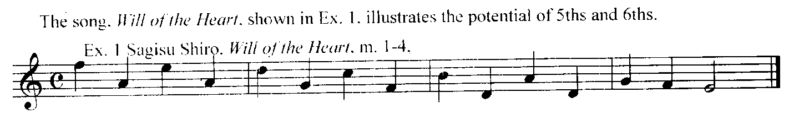

(C)
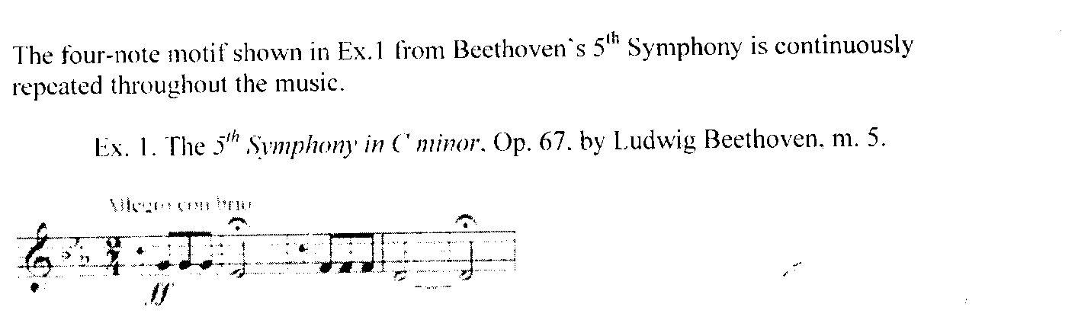

(D)
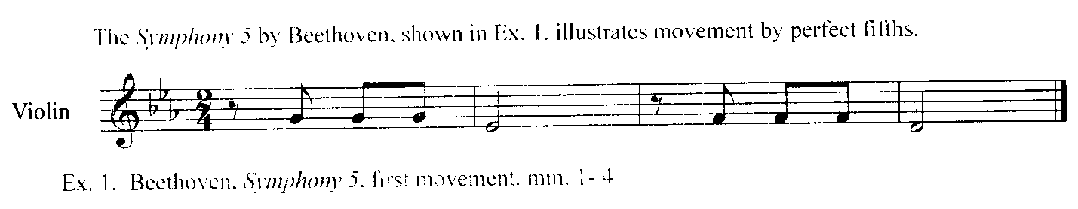

(E)

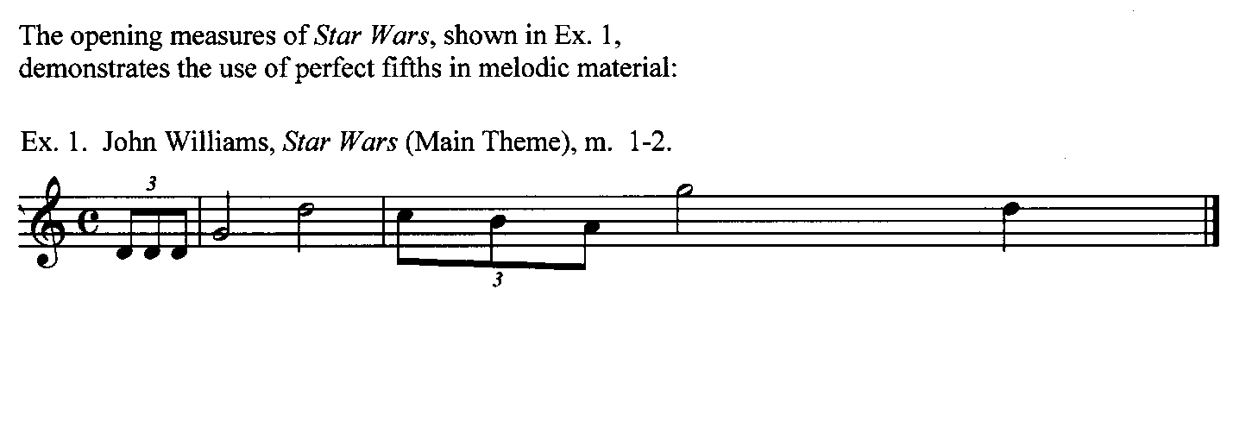(F)
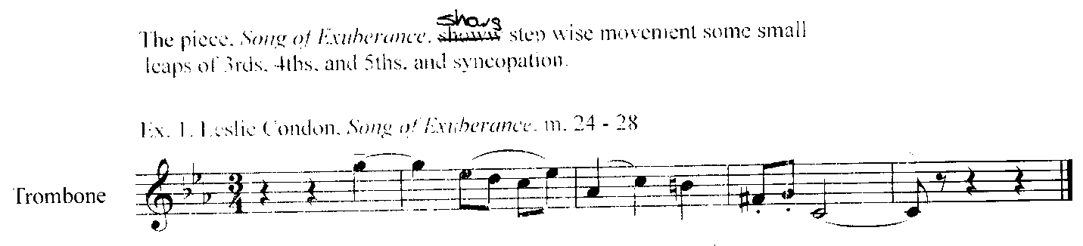

(G)
